ORTHOPAEDIC INSTRUMENTS
General Instruments
Allis Tissue Holding Forceps
Intended Use
Allis tissue holding forceps are essential general veterinary surgical instruments used to grasp and retract fascia, muscle, periosteum and organ tissue during orthopaedic and soft-tissue procedures in dogs and cats. They provide a secure hold during fracture exposure, wound closure and tissue manipulation without damaging delicate structures. | 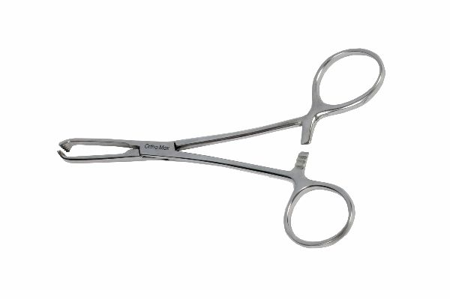
Function
The jaws feature multiple fine interlocking teeth that interdigitate when the ratchet handle is closed, gripping tissue securely without cutting. The ratchet mechanism locks the jaws at graduated pressure levels, maintaining constant grip tension without requiring continuous hand pressure and freeing the surgeon to use both hands for other tasks.
Advantages
Secure Ratcheted Tissue Grip: The self-locking ratchet mechanism maintains consistent tissue hold without hand fatigue, allowing prolonged retraction during lengthy orthopaedic procedures such as fracture plating and joint exploration in large-breed dogs.
Atraumatic Serrated Jaw Profile: The interlocking fine teeth distribute grip force over a wide contact area, minimising tissue crushing compared with smooth-jawed clamps while still preventing slip during periosteal retraction and wound edge manipulation.
FAQ
Q: What tissue types are Allis forceps used on in veterinary orthopaedics?
A: Allis forceps are used on fascia, muscle bellies, periosteum, joint capsule and skin edges during fracture exposure, arthrotomy and wound closure in dogs and cats.
Q: Do Allis forceps cause tissue damage?
A: The teeth cause minor tissue indentation but are considered acceptable for retraction during surgery. They are not recommended for prolonged grip on delicate vessels or visceral organs.

ORTHOPAEDIC INSTRUMENTS
General Instruments
BP Handle
Intended Use
The Bard-Parker (BP) scalpel handle is a foundational veterinary surgical instrument used to hold disposable scalpel blades for precise skin and tissue incisions during orthopaedic, soft-tissue and general surgical procedures in dogs and cats. Available in multiple sizes to accommodate different blade types and surgical access requirements. | 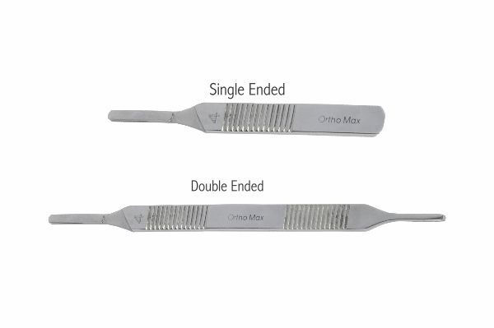
Function
The handle features a precision-machined blade slot with a spring-retaining groove that accepts the standardised shank of Bard-Parker disposable blades. The blade is loaded and unloaded using a needle holder to avoid sharps injury. The hexagonal or flat handle cross-section provides a non-slip grip for controlled scalpel pressure during incision.
Advantages
Universal Blade Compatibility: The standardised Bard-Parker slot accepts all common disposable blade sizes (10, 11, 15, 20, 22, 23, 24), allowing the same handle to be used for skin incisions, stab incisions and fine periosteal cuts without changing instruments.
Ergonomic Non-Slip Handle: The knurled stainless steel surface provides secure grip even through surgical gloves wetted with blood or saline, enabling precise incision control during delicate joint capsule and periosteal incisions in veterinary orthopaedics.
FAQ
Q: What is the most commonly used BP handle size in veterinary surgery?
A: Size 3 handles (for blades 10, 11, 12, 15) are most common in small animal surgery; size 4 handles (for blades 20–24) are used for large-breed dogs and equine procedures.
Q: How should disposable blades be safely removed from the handle?
A: Always use a needle holder or blade remover clamp to slide the blade off the handle; never remove blades with fingers to prevent sharps injuries to surgical staff.

ORTHOPAEDIC INSTRUMENTS
General Instruments
Dissecting Forceps - Adson
Intended Use
Adson dissecting forceps are precision thumb forceps used in veterinary orthopaedic and soft-tissue surgery to grasp, manipulate and stabilise tissue during incision, dissection and suturing. Their fine-toothed or smooth tips are ideal for delicate tissue handling near joints, vessels and nerves in dogs and cats. | 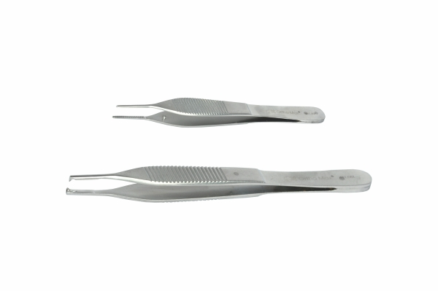
Function
The spring-action handle generates gripping force proportional to finger pressure applied to the two arms. Toothed jaws (1×2 or 2×3 configuration) pierce and hold tissue securely with minimal lateral spread; smooth jaws grip without penetration for vascular tissue. The lightweight design reduces hand fatigue during fine dissection work.
Advantages
Fine-Tip Precision for Delicate Structures: The narrow Adson tip profile allows precise tissue manipulation in confined surgical fields such as the carpal joint, stifle compartment and spinal canal without disturbing adjacent neurovascular structures.
Choice of Toothed or Smooth Jaw: Toothed Adson forceps securely grip fibrous tissue and skin; smooth jaws handle vessels and peritendinous tissue without puncture risk — the two configurations cover the full range of tissue types encountered in veterinary orthopaedic surgery.
FAQ
Q: What is the difference between Adson and standard tissue forceps?
A: Adson forceps have a wider, serrated platform at the proximal jaw that enhances grip stability; standard forceps have a narrower serrated tip. Adson forceps are preferred for skin closure and fascial dissection.
Q: Are Adson forceps used for suture placement?
A: Yes. Adson forceps are routinely used to stabilise wound edges and periosteum during suture placement, providing the precise tissue control needed for accurate knot positioning.

ORTHOPAEDIC INSTRUMENTS
General Instruments
Dissecting Micro Forceps
Intended Use
Dissecting micro forceps are ultra-fine precision instruments used in veterinary microsurgical and minimally invasive orthopaedic procedures to manipulate small nerves, vessels, tendons and joint structures in dogs and cats. They are essential for spinal surgery, peripheral nerve repair and fine tendon reconstruction in small animals. | 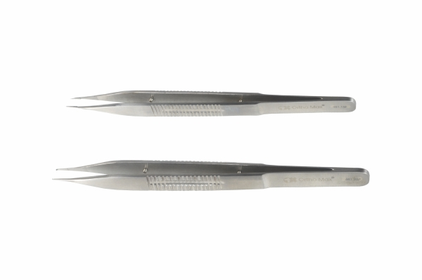
Function
The bayonet or straight shaft reduces hand shadow in deep surgical fields and under magnification. Spring-tempered arms provide consistent gripping force calibrated for delicate microstructures. The fine tip profile — typically 0.2–0.5 mm wide — allows precise tissue engagement under operating microscope or loupe magnification without collateral tissue disruption.
Advantages
Microsurgical Tip Precision: Sub-millimetre tip widths enable single-fascicle nerve manipulation and fine vessel anastomosis under magnification, supporting advanced veterinary neurosurgical and reconstructive orthopaedic procedures in small patients.
Low-Force Spring Mechanism: Calibrated spring tension generates only the tissue contact force needed for microstructure manipulation, preventing inadvertent crush injury to nerve fascicles and small-calibre vessels during delicate dissection.
FAQ
Q: What procedures in veterinary orthopaedics require micro forceps?
A: Micro forceps are used in peripheral nerve repair, spinal cord decompression, fine tendon anastomosis, arthroscopic instrument handling and minimally invasive joint surgery in small animals.
Q: How should micro forceps be sterilised?
A: Micro forceps should be sterilised using gravity or vacuum autoclave cycles with tip protectors in place to prevent tip deformation; ultrasonic cleaning before autoclaving removes biological debris from the fine tip.

ORTHOPAEDIC INSTRUMENTS
General Instruments
Kocher Clamps
Intended Use
Kocher clamps are heavy-duty haemostatic and tissue-grasping forceps used in veterinary orthopaedic and general surgery to clamp, retract and hold dense fibrous tissue, periosteum, fascia and bone fragments. Their robust toothed jaws provide a secure, non-slip grip on tough tissues encountered during fracture exposure and reduction. | 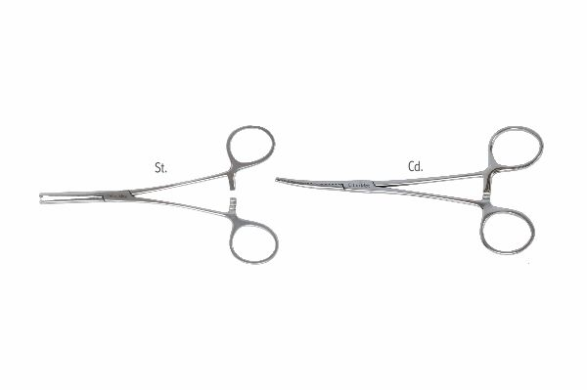
Function
The instrument features cross-serrated jaws with a terminal transverse tooth at the tip that bites into tissue to prevent slippage. A box-joint ratchet handle locks the jaws at multiple pressure settings. The heavy construction withstands the high gripping forces required to hold dense periosteum, joint capsule and fibrous scar tissue during orthopaedic dissection and fracture reduction.
Advantages
Secure Hold on Dense Fibrous Tissue: The terminal tooth and cross-serration pattern bite into periosteum, fascia and joint capsule to resist pullout under the substantial traction forces applied during fracture exposure, muscle retraction and fragment manipulation.
Versatile Haemostatic and Tissue-Holding Roles: Kocher clamps serve dual roles as haemostatic forceps for large vessel stumps and tissue-holding forceps for dense structures, reducing the instrument count required on the surgical tray during complex orthopaedic procedures.
FAQ
Q: How do Kocher clamps differ from Kelly or Crile haemostatic forceps?
A: Kocher clamps have a terminal tooth at the jaw tip for tissue penetration, making them more suited to dense fibrous tissue; Kelly and Crile forceps have smooth or cross-serrated jaws without teeth and are used for vessel clamping.
Q: What size Kocher clamps are used in veterinary orthopaedics?
A: Standard 14–16 cm straight or curved Kocher clamps are most common in small animal orthopaedics; longer 18–20 cm versions are used in large-breed dogs and equine procedures.

ORTHOPAEDIC INSTRUMENTS
General Instruments
Mixter Artery Forceps
Intended Use
Mixter artery forceps are long-nosed, right-angle haemostatic clamps used in veterinary orthopaedic and thoracic surgery to isolate, clamp and ligate blood vessels and tissue pedicles in deep or confined surgical fields. Their angled jaw design enables vessel isolation where straight forceps cannot reach in dogs and cats. | 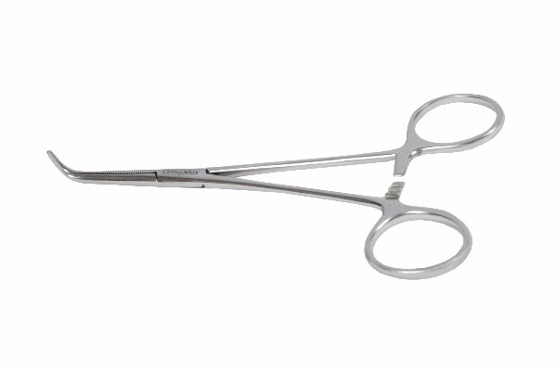
Function
The jaw is angled 90° to the handle shaft, allowing the tip to be passed around a vessel or tissue pedicle from a lateral approach and then closed to clamp the structure. The fully serrated jaws grip vessels securely without cutting. The standard ratchet handle locks the clamp at graded closure levels, maintaining vessel occlusion while the surgeon places a ligature.
Advantages
Right-Angle Jaw for Deep Vessel Access: The 90° jaw angle allows the forceps to be passed around vessels in the depth of thoracic, abdominal and pelvic surgical fields where the jaw of a straight clamp cannot be oriented correctly for vessel isolation.
Secure Ratchet Vessel Occlusion: The fully transversely serrated jaw surface provides reliable vessel occlusion without cutting through the vessel wall, maintaining haemostasis during ligature placement in vascular orthopaedic and spinal procedures.
FAQ
Q: What is the primary use of Mixter forceps in veterinary orthopaedics?
A: Mixter forceps are used to isolate and clamp deep vessels during spinal cord decompression, pelvic fracture repair and thoracic approaches, where their right-angle jaw enables vessel encirclement in confined spaces.
Q: Are Mixter forceps used for blunt dissection?
A: Yes. The closed tips can be inserted into tissue planes and opened to bluntly dissect tissue around vessels and nerves, particularly in deep pelvic and thoracic surgical corridors.

ORTHOPAEDIC INSTRUMENTS
General Instruments
Mosquito Artery Forceps
Intended Use
Mosquito artery forceps are fine-tipped haemostatic clamps used in veterinary orthopaedic and soft-tissue surgery to clamp small vessels and capillary bleeding points during fracture exposure and wound closure in dogs and cats. Their delicate jaws are ideal for haemostasis in small animals and paediatric orthopaedic patients. | 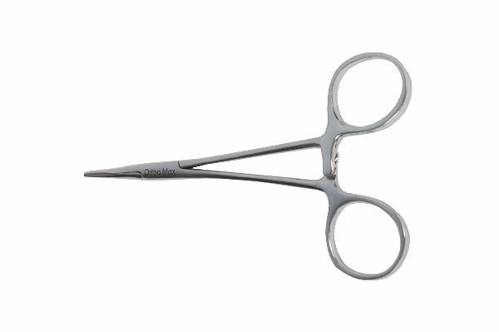
Function
The narrow, fully serrated jaws are sized for small-calibre vessels up to 2 mm diameter. The lightweight ratchet handle allows the clamp to be set on a vessel and left in situ without pulling surrounding tissue, leaving both hands free for dissection or suture placement. Available in straight and curved profiles for different access angles.
Advantages
Fine-Tipped Precision Haemostasis: The narrow mosquito jaw tip precisely grips individual small vessels and capillary bundles without incorporating surrounding tissue, minimising collateral tissue damage during fine haemostasis in small animal orthopaedic incisions.
Lightweight Self-Retaining Design: Once ratcheted closed on a vessel, the lightweight clamp remains in position without manual support, reducing the number of assistant hands needed to maintain haemostasis during fracture exposure and implant application.
FAQ
Q: What vessel size are mosquito forceps suitable for?
A: Mosquito forceps are designed for vessels up to approximately 2 mm diameter, making them ideal for subcutaneous and periosteal vessels in cats, toy breeds and small-breed paediatric patients.
Q: What is the difference between mosquito and Crile artery forceps?
A: Mosquito forceps are smaller with a finer jaw for tiny vessels; Crile forceps are larger and heavier for vessels up to 4–5 mm diameter in medium to large-breed dogs.

ORTHOPAEDIC INSTRUMENTS
General Instruments
Needle Holders - Crile Artery Forceps
Intended Use
Crile-pattern needle holders are dual-purpose instruments combining suture needle holding and artery clamping functions, widely used in veterinary orthopaedic and general surgery for wound closure, periosteal repair and vessel ligation in dogs and cats. Their heavy-duty jaws securely drive orthopaedic suture needles through tough fibrous tissue. | 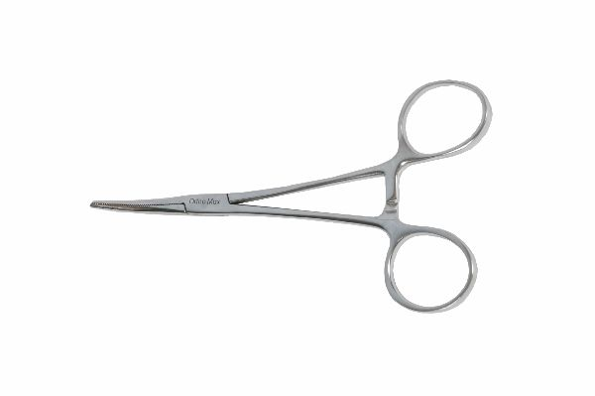
Function
The cross-serrated tungsten carbide or stainless steel jaws grip the suture needle shank firmly, preventing rotation during passage through periosteum, joint capsule and tendon. The box-joint ratchet handle locks the needle at the correct position for knot-tying. The robust Crile-pattern jaw also functions as a haemostatic clamp for medium-calibre vessels.
Advantages
Tungsten Carbide Jaw Insert Option: Tungsten carbide-tipped jaws grip suture needles with superior hold compared with plain stainless steel, preventing needle rotation during tough periosteal and fascial closure and extending jaw service life before re-tipping is required.
Dual Needle Holder and Haemostatic Function: The Crile-pattern jaw clamping force is sufficient for medium-calibre vessel ligation as well as needle holding, reducing the number of instrument exchanges needed during combined orthopaedic-soft-tissue procedures.
FAQ
Q: What suture sizes are Crile needle holders designed for?
A: Crile needle holders are suited to suture sizes 0 to 3-0, covering the heavy sutures used for joint capsule, periosteal and tendon closure in medium and large-breed dogs.
Q: When should a dedicated needle holder be chosen over a Crile clamp?
A: A dedicated Mayo-Hegar or Olsen-Hegar needle holder is preferred for fine suture work (4-0 and smaller); the Crile pattern is best for heavy sutures and combined needle-holding/vessel-clamping tasks.

ORTHOPAEDIC INSTRUMENTS
General Instruments
Scissors - Mayo
Intended Use
Mayo scissors are heavy-duty general veterinary surgical scissors used to cut dense fibrous tissue, fascia, periosteum, joint capsule and suture material during orthopaedic procedures in dogs and cats. Their robust blades are the workhorse scissors for tissue cutting in fracture exposure and wound closure. | 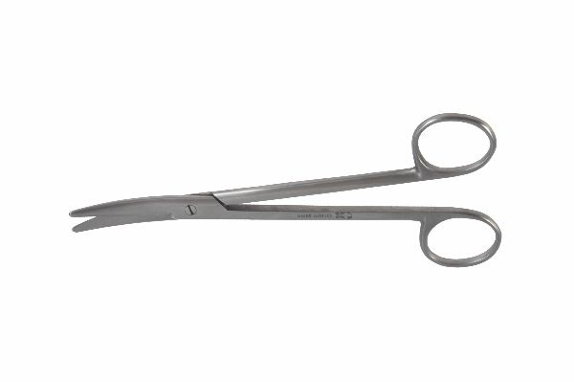
Function
The thick, semi-blunt blades are manufactured from high-carbon stainless steel and feature a semi-sharp semi-blunt tip combination (or fully blunt for deep tissue cutting). The strong shear geometry of the blades cuts through tough fibrous structures with minimal hand force. Available in straight and curved profiles to suit open and deep-field tissue cutting.
Advantages
Heavy-Duty Blade Strength for Tough Tissues: The thick, high-carbon stainless steel blades resist blade deflection when cutting dense fascia, joint capsule and scar tissue, maintaining a clean cut edge that minimises tissue trauma at fracture exposure sites.
Straight and Curved Profiles Available: Straight Mayo scissors cut tissue at the surface; curved blades reach around structures in the depth of the wound, together covering the full range of tissue-cutting tasks in veterinary orthopaedic and soft-tissue surgery.
FAQ
Q: Can Mayo scissors be used to cut suture material?
A: Yes. Mayo scissors are routinely used for suture cutting; however, dedicated suture scissors should be used for cutting mono-filament sutures to preserve the blade edge for tissue cutting.
Q: What is the difference between Mayo and Metzenbaum scissors in veterinary surgery?
A: Mayo scissors are heavier with shorter blades relative to handle length for cutting tough tissues; Metzenbaum scissors are lighter with longer, thinner blades for delicate tissue dissection.

ORTHOPAEDIC INSTRUMENTS
General Instruments
Scissors - Metzenbaum
Intended Use
Metzenbaum scissors are delicate dissecting scissors used in veterinary orthopaedic and soft-tissue surgery for fine tissue dissection around nerves, vessels, tendons and joint structures in dogs and cats. Their long, slender blades enable precise dissection in deep wounds and narrow anatomical corridors. | 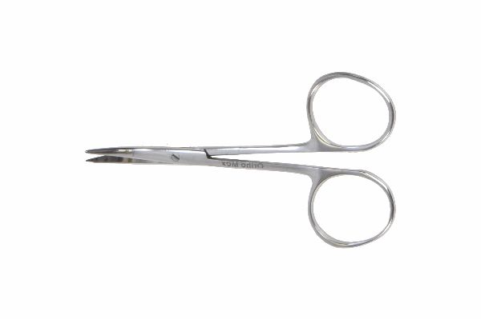
Function
The long, slender blades with a relatively short cutting edge near the tip facilitate precise tissue separation by both cutting and spreading — the closed tips are inserted into tissue planes and opened to bluntly dissect tissue planes before snipping. The gentle curvature of curved Metzenbaum scissors follows anatomical contours during vessel and nerve isolation.
Advantages
Long Blade for Deep-Field Dissection: The extended blade-to-handle ratio allows the scissor tips to reach deep anatomical compartments — spinal canal, hip joint, brachial plexus — while keeping the surgeon's hand at the wound surface, improving visibility and precision.
Fine-Tip Blunt Dissection Capability: The rounded tip profile allows atraumatic tissue plane development by spreading — critical when dissecting around peripheral nerves and vessels during orthopaedic approaches to the spine, hip and brachial plexus region.
FAQ
Q: Should Metzenbaum scissors be used to cut sutures?
A: No. Cutting sutures rapidly dulls the delicate Metzenbaum blades. Dedicated suture scissors or Mayo scissors should always be used for suture cutting.
Q: What sizes of Metzenbaum scissors are used in veterinary surgery?
A: 14 cm scissors are standard for cats and small dogs; 18–23 cm versions are used for deep dissection in large-breed dogs and thoracic spinal approaches.

ORTHOPAEDIC INSTRUMENTS
General Instruments
Scissors - Northbent Suture Cutting
Intended Use
Northbent suture scissors are angled-blade scissors used in veterinary surgery to cut sutures flush with the tissue surface in deep or confined wounds. Their upward-angled blade tip enables suture cutting without the instrument shaft obstructing the surgeon's view or contacting the wound edges in orthopaedic incisions. | 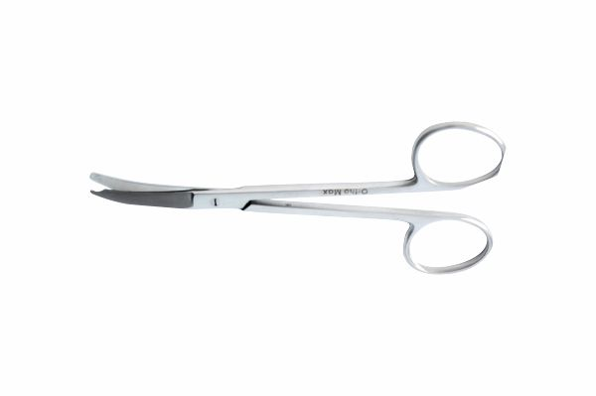
Function
The blade is angled at approximately 45° relative to the handle axis. This angle allows the lower blade to slide under the suture knot at the tissue surface without the handle elevating above the wound plane, enabling suture cutting at skin level or within deep anatomical compartments where straight scissors cannot access the suture without obscuring the field.
Advantages
Flush Suture Cutting in Deep Wounds: The northbent angle allows suture threads to be cut at the knot level even in deep, narrow wound channels — essential for removing buried sutures in joint capsule, periosteum and deep fascial layers without disturbing surrounding tissue.
Unobstructed Wound Visibility: The angled blade keeps the scissor handle out of the surgeon's direct line of sight during cutting, maintaining visibility of the suture and tissue surface and reducing the risk of inadvertent tissue cuts from misdirected scissors.
FAQ
Q: What is the clinical difference between northbent and standard suture scissors?
A: Northbent scissors cut sutures in deep wounds where the surgeon cannot angle a straight-bladed scissor without obstructing the field; standard scissors are used for superficial accessible suture trimming.
Q: Are northbent scissors used for tissue cutting as well as sutures?
A: They are primarily suture scissors; their angled blades are not optimised for tissue cutting and blade dulling from tissue would compromise their primary suture-cutting function.

ORTHOPAEDIC INSTRUMENTS
General Instruments
Scissors - Heath Stitch Cutting
Intended Use
Heath stitch scissors are specialised veterinary surgical scissors designed for safe, rapid removal of interrupted and mattress skin sutures during post-orthopaedic wound check and suture removal in dogs and cats. The hooked lower blade lifts and isolates each suture thread before cutting to prevent inadvertent skin laceration. | 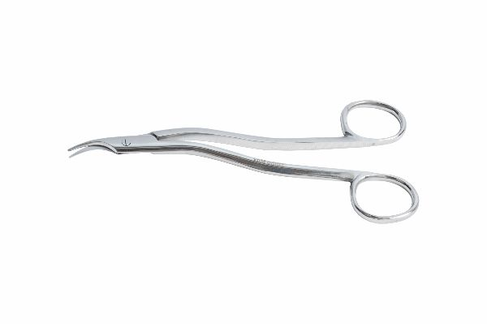
Function
The lower blade features a curved hook that slides under the suture loop at skin level, lifting the thread away from the underlying skin surface. The upper flat blade then shears against the hooked blade to cut the lifted thread cleanly. This design prevents the blade tip from contacting skin and eliminates the risk of cutting the wound edge during suture removal.
Advantages
Safe Hook Design Prevents Skin Injury: The hooked lower blade lifts each suture away from the skin before cutting, virtually eliminating the risk of accidental skin laceration during suture removal — particularly important in post-orthopaedic incisions under tension or oedema.
Efficient High-Volume Suture Removal: The smooth hook-and-cut motion enables rapid sequential removal of multiple sutures across long orthopaedic incisions, reducing patient restraint time and nursing staff workload during postoperative check consultations.
FAQ
Q: Can Heath scissors be used to remove staples?
A: No. Heath scissors are designed for suture thread removal only; staple removal requires a dedicated staple remover instrument to safely evert and extract skin staples.
Q: How should Heath scissors be maintained to ensure a clean cut?
A: Blades should be kept sharp and free of debris; dull scissors drag rather than cut and may require multiple attempts, increasing patient discomfort during suture removal.

ORTHOPAEDIC INSTRUMENTS
General Instruments
Sponge Holding Forceps
Intended Use
Sponge holding forceps are large ring-handled forceps used in veterinary orthopaedic and general surgery to hold gauze swabs for surgical field preparation (skin scrubbing), wound lavage, haemostasis and bone fragment stabilisation during fracture fixation procedures in dogs and cats. | 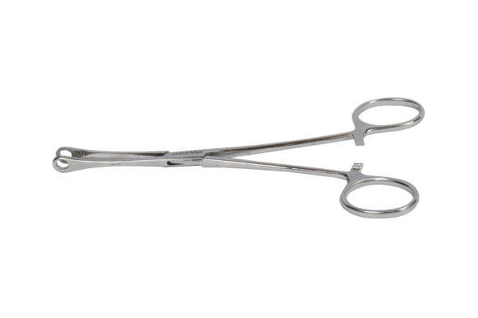
Function
The wide oval ring jaws grip a folded gauze swab securely when the ratchet handle is closed. The long handle keeps the surgeon's hand at distance from the operative field during antiseptic skin preparation. In orthopaedic surgery, sponge forceps are also used to grip and position large bone fragments during reduction and to pack haemostatic material into bleeding cancellous bone beds.
Advantages
Large Ring Jaw for Secure Swab Grip: The wide oval ring jaw prevents folded gauze from slipping during vigorous skin preparation and wound lavage, ensuring consistent antiseptic coverage and haemostatic packing contact with the surgical field.
Versatile Intraoperative Uses: Beyond swab holding, the broad ring jaw can grip large cancellous bone fragments, pack haemostatic agents and retract bowel loops during pelvic fracture reduction, making sponge forceps among the most versatile instruments on the orthopaedic surgical tray.
FAQ
Q: Can sponge holding forceps be used to handle bone grafts?
A: Yes. The ring jaw can gently grip cancellous bone graft blocks for positioning into defects during fracture repair and bone grafting procedures without fragmenting the graft material.
Q: What sizes are available for veterinary use?
A: Standard 24 cm and 26 cm lengths are used in medium and large-breed dogs; 18 cm versions are appropriate for cats and toy breeds where a shorter instrument avoids field crowding.

ORTHOPAEDIC INSTRUMENTS
General Instruments
Towel Forceps (Guarded)
Intended Use
Guarded towel forceps are draping clamps used in veterinary orthopaedic surgery to secure sterile surgical drapes to the patient's skin, maintaining a sterile field during fracture fixation, joint surgery and spinal procedures in dogs and cats. The guarded tip prevents accidental patient skin injury during drape placement. | 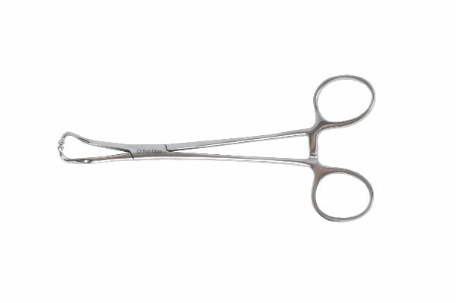
Function
The pointed tips engage and penetrate the surgical drape to anchor it to adjacent drape layers or skin. The guard (a small plastic or metal shield around the tip) limits the depth of tip penetration, preventing the sharp point from piercing through the drape into the patient's skin or underlying tissue. The ratchet handle maintains drape tension throughout the procedure.
Advantages
Tip Guard Prevents Patient Injury: The penetration-limiting guard around the tip ensures the forcep secures multiple drape layers without the sharp point inadvertently puncturing the patient's skin — critical for maintaining sterile field integrity during prolonged orthopaedic procedures.
Reliable Drape Tension Maintenance: The ratcheted handle holds the drape under consistent tension throughout the procedure, preventing drape slippage and sterile field contamination that would necessitate a complete re-draping during fracture fixation surgery.
FAQ
Q: How many towel forceps are typically needed to secure a drape pack?
A: A minimum of four towel forceps are used for square draping; six to eight are required for complex limb draping in orthopaedic procedures requiring complete extremity access.
Q: Can guarded towel forceps puncture gloves?
A: The guarded tip significantly reduces glove puncture risk compared with unguarded Backhaus-type forceps; however, care should still be taken during handling and sterilisation to prevent accidental injury.

